REVERING OF DIGITS OF INTEGER

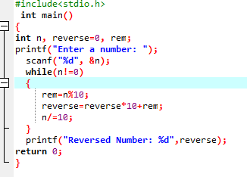

OUTPUT

